**2016**

**Florida Conference of Historians**

**56th Annual Meeting**

**February 18-20**

**Student Union**

**University of Central Florida**

**Orlando, Florida**

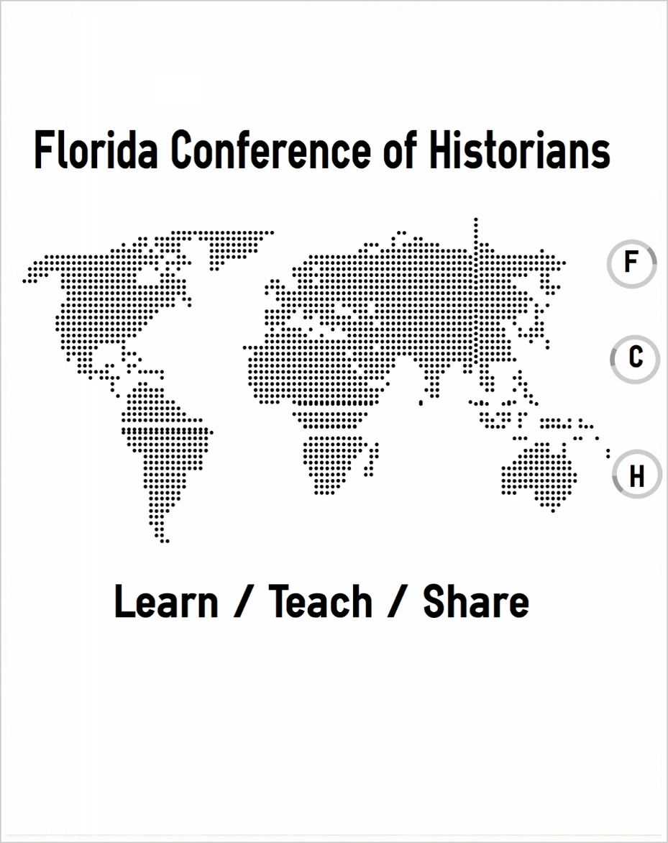

**Sponsored by the University of Central Florida and**

**Alpha Gamma Chi chapter of Phi Alpha Theta**

**Local Arrangements Chair**

Patricia Farless

University of Central Florida

**Program Co-Chairs**

Patricia Farless

University of Central Florida

Jesse Hingson

Jacksonville University

**Officers of the**

**Florida Conference of Historians, 2016-2017**

President Patricia Farless

University of Central Florida

President-Elect Thomas Donaldson

Florida SouthWestern State College

Treasurer Jesse Hingson

Jacksonville University

Secretary David Proctor

Tallahassee Community College

**FCH Annals:**

**The Journal of the Florida Conference of Historians**

Senior Editor

Michael S. Cole

Florida Gulf Coast University

**General Information**

**Air Travel to Orlando**

If traveling to the meeting by air, the Local Arrangements Chair recommends flying into either Sanford-Orlando International Airport (website: http://www.orlandosanfordairport.com/) or the Orlando International Airport (website: http://www.orlandoairports.net/). Both airports offer car rental and taxi services.

**Driving Directions to the University of Central Florida**

From Orlando International Airport:

Go east on 528 to 417 north. Take 417 North to University Blvd. Exit east onto University Blvd. Continue east on University Blvd. for two miles, and it will take you to the main UCF entrance.

**From The North**:

Option 1: Take the Florida Turnpike South to 408 east. Take 408 east to 417 North toward Sanford. Exit off of 417 to University Blvd. East. Take University Blvd 2 to the main UCF entrance.

Option 2: Take I-95 South to SR 50 West. Take SR 50 to Alafaya Trail. Make a right hand turn on Alafaya Trail. Continue on Alafaya Trail to University Blvd. Make a right turn on University Blvd. and you are on campus

**From The South and Melbourne Area**:

Option 1: Take the Florida Turnpike north and exit onto I-4 East. Continue until you reach 408 east. Take 408 east to 417 North toward Sanford. Exit off of 417 to University Blvd East. Continue on University Blvd. for 2 miles and it will take you to the main UCF entrance.

Option 2: Take I-95 north to 520 West. Continue West and the road will merge with SR 50. Take SR 50 West to Alafaya Trail. Make a right turn on Alafaya Trail. Continue for 2 miles to University Blvd. Make a right turn on University Blvd. and you will be on campus.

**From The East, Titusville, and Daytona**:

Option 1: Take Highway 50 West to Alafaya Trail. Turn right on Alafaya Trail, go north for two miles. Turn right onto University Blvd. and you are on campus.

Option 2: Take I-4 West to 417 South. Exit off of 417 at University Blvd. East. Continue on University Blvd East and it will take you to the main UCF entrance.

**From The Tampa Area**:

Take I-4 east to 408 east toward Titusville. Take 408 to 417 North toward Sanford. Exit off of 417 at University Blvd. East. Take University Blvd 2 to the main UCF entrance.

Directions to and Parking for Burnett Honors College after Arriving at UCF

**Parking at UCF**

UCF’s History Department is providing parking permits for free to all participants who would like to park on campus on Friday and Saturday. **Please contact Jesse Hingson (jhingso@ju.edu) if you would like a parking pass and indicate which day(s) (Friday or Saturday or both).** **Daily permits are valid only in the GREEN spaces of the “D” garage.** When you enter the campus on University Blvd (the main entrance), take a right onto Gemini Blvd. Continue until you arrive at the “D” garage, located on the left. If you park elsewhere on campus without a visitor’s parking pass, you may get ticketed.

**Campus Map (also see page 5) and Parking Guide**

http://parking.ucf.edu

http://cdn.ucf.edu/map/printable/UCF-Campus-Map-2014.pdf

**Lodging: DoubleTree by Hilton Hotel Orlando East—UCF Area**

Lodging will be available at the DoubleTree by Hilton Hotel Orlando East-UCF Area for the conference rate. The street address for the hotel is: **12125 High Tech Avenue; Orlando, Florida 32817**. For more information on transportation and directions to the hotel, please go to:

http://doubletree3.hilton.com/en/hotels/florida/doubletree-by-hilton-hotel-orlando-east-ucf-area-ORLOEDT/maps-directions/index.html

Except for the welcome reception and plenary session at the hotel on Thursday evening, all conference activities will take place on the main campus of the University of Central Florida across the street from the conference hotel. You may pick up your badge, program, and a copy of the *FCH Annals* at the Thursday evening welcome reception.

**Shuttle Service between the DoubleTree Hotel and UCF Campus**

The FCH will sponsor free shuttle service on the “FCH Shuttle” to and from UCF campus. On both Friday and Saturday morning, there will be one shuttle trip that will pick up directly in front of the hotel lobby and drop off next to the UCF Student Union. There will be another shuttle on Friday and Saturday evening that will pick up next to the Student Union and drop off at the hotel. Please note the times for shuttle service in the program.

Throughout the day, UCF provides free shuttle service every 10-15 minutes. The shuttle stop is located at the “Plaza on University” (five minute walk). Stepping out in front of the hotel lobby, you will see a tan and orange resident hall building. You will take the sidewalk (along Strategy Boulevard) that leads around the building to the shuttle stop that stops directly in front of the residence hall (you will see a McDonald’s in the plaza). The shuttle is labeled “UCF Shuttle”. Please don’t confuse the shuttle with the Lynx bus system, which has a stop located on Alafaya Trail.

**UCF Student Union**

All conference activity on Friday and Saturday will take place at the Student Union on UCF’s main campus. You may pick up your badge, program, and a copy of the *FCH Annals* at the registration table. On Friday, conference activity will take place on the second floor. On Saturday, conference activity will take place on the main floor. Please consult the program for the exact location of panels, plenary sessions, and special events.

* Restaurant Options Available in the UCF Student Union
  + Asian Chao
  + Corner Cafe
  + Greens Salad Bar
  + Huey Magoo's Express
  + Joffrey's Coffee
  + Qdoba Mexican Grill
  + Smoothie King
  + Subway
  + Wackadoo’s Grub and Brew

**UCF Campus Map**

**(STUN=Student Union; PGD=Parking Garage “D”; LIB=Hitt Library)**

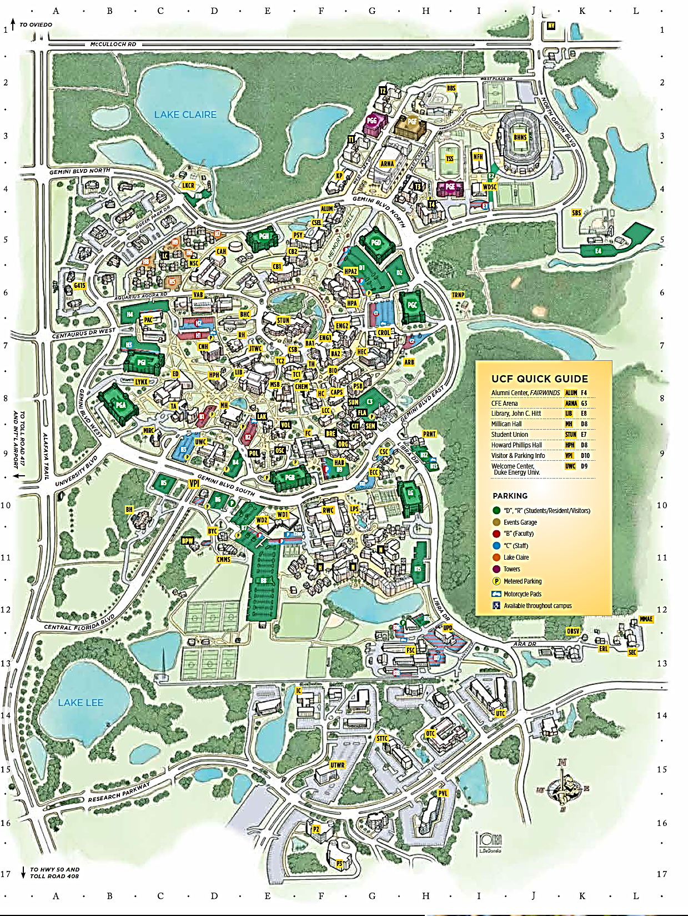



**Thursday, February 18, 2016**

**8:30 AM-5:00 PM: 2016 THATCamp Florida,**

**An Unconference on the Humanities and Technology**

Co-Sponsored by THATCamp and the

University of Central Florida’s Public History Program

Prior to the 2016 FCH Annual Meeting, registrants are invited to participate in THATCamp Florida. THATCamp (The Humanities and Technology Camp) is an informal and free “unconference” where you can discuss digital projects, learn skills, and brainstorm Digital Humanities initiatives. Topics are endless and proposed on the spot. Examples of possible themes for discussion may include:

* Mapping Tools for the Classroom
* Social Media Tools
* Digital Archiving
* Geographic Information Systems
* Using Digital Databases

For more information about registering, proposing a topic, and attending, please visit: http://florida2016.thatcamp.org/

The location of THATCamp Florida will be:

University of Central Florida

John C. Hitt Library

12701 Pegasus Drive

Orlando, FL 32816

FREE Registration and Continental Breakfast are included

$10-$20 Suggested Donation

**6:00 PM-6:30 PM**

**FCH Registration and Welcome Reception**

Location: DoubleTree Hotel-Orlando East

Waterford C

**Welcoming Remarks**

Dr. John Sacher

Chair, History Department

University of Central Florida

Refreshments and Appetizers Provided

Co-Sponsored with THATCamp Florida

**6:30 PM-9:00 PM**

**Plenary Session:**

**Documentary Film Screening and Discussion**

Location: Avalon Amphitheatre

(Max. Capacity: 50 seats)

Robert Cassanello

University of Central Florida

“Short Films on Academic Freedom

and Florida Colleges”

This session will feature two short films about the Florida legislature’s efforts to ban the teaching of evolution, sociology, George Bernard Shaw, and Sigmund Freud in addition to the state legislature’s efforts to investigate and persecute public university faculty and students who were GLBT. Robert Cassanello and Lisa Mills will screen and discuss their short documentaries that address academic freedom and the courses they taught that produced these award winning documentaries. **Please be advised that seating is limited to 50 on a first come, first serve basis.**

**Friday, February 19, 2016**

**8:30 AM: Shuttle Bus from DoubleTree to UCF Student Union**

**9:00 AM-4:00 PM: Registration**

Location: UCF Student Union, 2nd Floor, Pre-function area in front of Key West

* Refreshments will be provided during the morning sessions

**Session One: Friday, 9:00 AM-10:15 AM**

**Panel 1A**: World War and Mentalité during the Twentieth Century

Meeting Room: Sand Key, Room 220

*“War is Different": How World War I Transformed Traditional Jewish Attitudes to Military Activity*

Stuart Cohen, Bar-Ilan University (Israel)

*French Intellectuals and the Idea of Progress during the First World War*

Khali Navarro, University of Central Florida

*Centennial Anniversaries: Contrasting the Alliance-Systems of World War I vs. World War II (1870s-1945)*

Marco Rimanelli, Saint Leo University

Chair and Discussant: Nick Steneck, Wesleyan College

**Panel 1B**: New Perspectives on Post-1945 Florida

Special Interest Section: Florida History

Meeting Room: Cedar Key, Room 223

*Tampa's Urbanized, Suburbanized, and Romanticized Waterway: Polluting, Preserving, and Processing the Hillsborough River in the 1960s and 70s*

Brad Massey, Polk State College and University of Florida

*Reaction to the Cuban Missile Crisis as Reported by Florida Newspapers*

Michael Epple, Florida Gulf Coast University

*Ruskin, Florida: An Arts and Crafts Movement Architecture and Social Philosophy Experiment: Analysis and Perspectives*

Tom Adamich, Visiting Librarian Service

Chair: Sean McMahon, Florida Gateway College

Discussant: Charles Gallagher, Boston College

**Panel 1C**: Guiding the Course of History:

Archival Outreach and Advocacy

Meeting Room: Egmont Key, Room 224

*Social Media and Pathways to Success*

Gerrianne Schaad, McKay Archives, Florida Southern College

*Mentoring and Training Undergraduates in the Archival World*

Jeffrey Zines, McKay Archives, Florida Southern College

*Undergraduate Archival Work:*

*From Pulling Staples to Writing Finding Aids*

Anthony Woodside, McKay Archives, Florida Southern College

Chair: Gerrianne Schaad, Florida Southern College

Discussant: David Benjamin, University of Central Florida

**Session Two: Friday, 10:30 AM-11:45 AM**

**Panel 2A**: Still an “Unfinished American Revolution”?

New Studies on the Reconstruction Period

Meeting Room: Egmont Key, Room 224

*"Democratic Packing Horses No More":*

*The Fenian Brotherhood and the Radical Republican Agenda in 1867*

Matthew Knight, University of South Florida

*Carnival of Crime*

R. Gregory Lande, Independent Scholar

Chair and Discussant: David Proctor, Tallahassee Community College

**Panel 2B:** Guns, Germs, Steel, and Language:

European Expansion in the Americas during the Sixteenth Century

Meeting Room: Sand Key, Room 220

*Alvarado's Leap: Construction of a Legend*

Steven Scheuler, Valdosta State University

*A Spanish Entrepreneur in Early Colonial Mexico*

Michael S. Cole, Florida Gulf Coast University

*Objects of Exchange, Objects of Discord:*

*Trade, Inter-Cultural Communication, and Diplomatic Breakdown in Early Colonial Northern Florida*

Christophe Boucher, College of Charleston

Chair and Discussant: Deborah L. Bauer, University of South Florida

**Panel 2C:** Not the “Dark Ages”:The Vibrant Medieval World

Meeting Room: Cedar Key, Room 223

*'Ubi apostolica forma et vita quam iactatis?':*

*Evaluating Textual Representations of Cathar Asceticism, c. 1100-1300*

Bryan E. Peterson, University of North Florida

Chair and Discussant: Peter Larson, University of Central Florida

**12:00 PM-1:45 PM: Luncheon on the Scholarship of Teaching and Learning**

* Location: Key West 218
* Boxed lunches are free to the first 75 participants and will be provided on a first come, first serve basis.

**The Scholarship of Teaching and Learning (SoTL):**

**An Overview of What It Is, Why You Should Do It,**

**and How to Get Started**

Dr. Daniel S. Murphree

Associate Professor of History and

Assistant Editor of the *Florida Historical Quarterly*

Many people have heard the term “Scholarship of Teaching and Learning”, or its more frequently referenced acronym, “SoTL”, but few instructors of History at the college and university level contribute to it.  This session is devoted to outlining the basic goals of SoTL and making a case for why you should consider producing such scholarship related to the courses you teach.  Examples of SoTL articles, journals, and topics will be discussed and audience members are encouraged to ask questions about the process and work with one another in fostering SoTL collaborations.

**Session Three: Friday, 2:00 PM-3:15 PM**

**Panel 3A**: Women, the Environment, and Food

Special Interest Section: Florida History

Meeting Room: Cedar Key, Room 223

*Jane Nickerson: First New York Times Food Editor and*

*Later Lakeland Ledger Food Editor*

Kimberly Voss, University of Central Florida

*Florida Women Saving Natural Resources*

Leslie Kemp Poole, Rollins College

*Cracker Culture and Cuisine*

Peggy Macdonald, Matheson History Museum

Chair and Discussant: Kimberly Voss, University of Central Florida

**Panel 3B:** The Specter of Mass Killing and Genocide

Meeting Room: Sand Key, Room 220

*Fostering Empathy for Distant Suffering:*

*Karen Jeppe and the Danish Friends of Armenia*

Jonas Kauffeldt University of North Georgia

*The Role of the Office of kārguzār Concerning the Attack on the Jewish Ghetto in Kermanshah in 1909*

Parisa Mohammadi Kasir Abadi, Shahid Beheshti University (Iran)

*Ukrainian National Movements and the Holocaust*

Michael Gesin, Worcester State University

Chair and Discussant: Charles R. Gallagher, Boston College

**Panel 3C:** Race and Politics in the Sunshine State

Special Interest Section: Florida History

Meeting Room: Egmont Key, Room 224

*John H. Eaton, Jackson Protégé, as Governor of Florida, 1834-1836*

James M. Denham, Florida Southern College

*Seizing the Opportunity:*

*African American Education in Mandarin, 1868-1920*

Jay Smith, University of North Florida

Chair and Discussant: Sean McMahon, Florida Gateway College

**Panel 3D:** The Politics of the US Civil War

Meeting Room: Pensacola Board Room 222

*Noisy Copperheads: Pesky Protectors of Civil Liberties*

Kenneth Hoffman, Independent Scholar

*"The Dead of Antietam" through the Public Eye*

Brandon Freeman, West Chester University

Chair and Discussant: John M. Sacher, University of Central Florida

**Session Four: Friday, 3:30 PM-4:45 PM**

**Panel 4A:** Ideology and Community in the Americas during the Early Nineteenth Century

Meeting Room: Pensacola Board Room 222

*"The Pure Lava of Anti-Masonry": The First Congregational Church of Thetford, Vermont and the Anti-Masonic Struggle, 1829-1833*

Mike Davis, Northwest Florida State College

*"Public and Notorious": Conflicts over Political Denunciations in Córdoba, Argentina during the Rosas Era*

Jesse Hingson, Jacksonville University

Chair and Discussant: David Proctor, Tallahassee Community College

**Panel 4B:** The Decline of Slavery in the Americas

Meeting Room: Sand Key, Room 220

*Freedom Papers: Acts of Emancipation from Revolutionary Haiti in the University of Florida Archives*

David Allen Harvey, New College of Florida

*Premature Abolition, Ethnocentrism and Bold Blackness:*

*Race Relations in the Cayman Islands, 1834-1840*

Christopher A. Williams, University College of the Cayman Islands

*Runaway Slaves in the Early National Lower Mississippi Valley:*

*A New Census and Analysis*

Patrick Luck, Florida Polytechnic University

Chair and Discussant: Craig Buettinger, Jacksonville University

**Panel 4C:** Saloons, Speakeasies, and Sociability in a New South City, 1880s-1920s

Special Interest Section: Florida History

Meeting Room: Cedar Key, Room 223

*Saloons: A Cultural Battleground in Tampa, 1886-1919*

Andrew Huse, University of South Florida Libraries

*Barbershops, Saloons, and Black Male Sociability in*

*Early-Twentieth-Century Tampa*

Charles McGraw, University of Tampa

*Downtown Club Key to Prohibition-Era Tampa: The 1927 Key Club Case*

Rodney Kite-Powell, Tampa Bay History Center

Chair and Discussant:

Brad Massey, Polk State College and University of Florida

**Panel 4D:** Teaching and Researching History in the Digital Age

Special Interest Section: Media, Arts, and Culture

Meeting Room: Egmont Key, Room 224

*Exploring the Community:*

*Developing a Mobile Academic Research Application*

Julian C. Chambliss, Rollins College

*Connecting Past to Present:*

*Using New Media Theory in Museum Website Development*

Danielle McEwen, Texas State University

*It's a Great Big Beautiful Tomorrow, on the Internet Every Day:*

*Using Cultural Relics to Teach History in the Digital Age*

Daniel Vogel, Texas Christian University

Chair and Discussant: Thomas Donaldson,

Florida SouthWestern State College

**Panel 4E**: Roundtable Discussion, “Creating a Smoother Transition for Transfer Students Through Improved Faculty Communication and Best Teaching Practices”  
Meeting Room: Siesta Key, Board Room 225

Dr. Martha Brenckle, University of Central Florida

Dr. Heather Bryson, Valencia College

Ms. Nancy Maurer, Valencia College and University of Central Florida

Dr. Sean McMahon, Florida Gateway College  
Dr. David Proctor, Tallahassee Community College  
Dr. Amanda Snyder, University of Central Florida

Facilitator: Patricia Farless, University of Central Florida

**5:00 PM-7:00 PM: Plenary Session**

**“Perspectives on Public History: UCF’s Hands-On Approach to History outside the Classroom”**

The University of Central Florida History Department offers students, faculty and community members opportunities to engage in public history through digital initiatives, podcasting, oral history projects, interdisciplinary exhibit curation, and the *Florida Historical Quarterly*. This session includes a project-focused faculty panel and interactive presentations featuring students.

**Agenda**

5:00 PM-5:20 PM

Social Break and Refreshments

Meeting Room: Key West 218

5:20 PM-5:25 PM

Welcome and Introductions

Scot French

University of Central Florida

5:30 PM-6:15 PM

Panel

6:15 PM-6:45 PM

Breakout Sessions

6:45 PM-7:00 PM

Event Breakdown

**Featured Projects and Topics**

***Public History in the Digital Age***

Meeting Room: Key West 218

Scot French

Director of Public History and Associate Professor of History

Featuring research and interactive presentations by:

David Morton, Texts & Technology Ph.D. Candidate

Holly Baker, History Graduate Student  
Mark Barnes, History Graduate Student

Garrett Hillyer, History Graduate Student

Erin Montgomery, History Graduate Student

Drew Padgett, History Graduate Student

Mike Partain, History Graduate Student

***Florida Historical Quarterly:***

***Scholarly Journals and Public Audiences***

Meeting Room: Sand Key, Room 220

Dan Murphree,

Assistant Editor and Associate Professor of History

Graciela Gómez, History Undergraduate Student

***A History of Central Florida Podcast Project***

Meeting Room: Pensacola Board Room 222

Robert Cassanello

Associate Professor of History

***Building a Framework for Public History***

Meeting Room: Cedar Key, Room 223

Rosalind Beiler

Associate Professor of History

***Interdisciplinary Approaches to Exhibit Curation***

Meeting Room: Egmont Key, Room 224

Keri Watson

Assistant Professor of Art History

School of Visual Arts and Design

Affiliated Faculty, Texts and Technology and Women's Studies

***Capturing Stories of Service:***

***UCF Community Veterans History Project***

Meeting Room: Siesta Key, Board Room 225

Barbara Gannon

Assistant Professor of History and

Director of UCF Community Veterans History Project

Tyler Campbell

History Graduate Student

**7:15 PM: Shuttle Bus from UCF Student Union to DoubleTree Hotel**

**Saturday, February 20, 2016**

**8:30 AM: Shuttle Bus from DoubleTree to UCF Student Union**

**9:00 AM-12:00 PM: Registration**

Location: UCF Student Union, Ground Floor, Pre-Function Area in front of Pegasus Ballrooms

* Refreshments will be provided during the morning sessions

**Session Five: Saturday, 9:00 AM-10:15 AM**

**Panel 5A**: Promoting the "New South" during the Twentieth Century

Meeting Room: Pegasus A

*Southern Capitalism Looking South: Pan-Americanism and the Language of Business Expansion, 1906-1920*

Brendan Goff, New College of Florida

*NASA Launches Florida, Alabama, Mississippi, Louisiana, and Texas into Orbit: How America's Space Program Contributed to the Gulf South's Economic Growth, Scientific Development, and Modernization during the late Twentieth Century*

Kevin M. Brady, Tidewater Community College

*Music, High Culture, and Race in a Southern City:*

*Macon, Georgia in the 1950s*

Robert Burnham, Middle Georgia State University

Chair and Discussant: Seth Weitz, Dalton State College

**Panel 5B:** Heritage and Tourism in Modern Asia

Meeting Room: Pegasus B

*The City of Tianjin in the Context of Cosmopolitan Urban Heritage and Identity Recreation*

Hong Zhang, University of Central Florida

*Conquering Tourism:*

*The Roots and Effects of Tourism in Occupation-era Japan*

Christian Lazenby, University of North Florida

Chair and Discussant: Sungshin Kim, University of North Georgia

**Panel 5C:** Politics and Culture in the Contemporary World

Meeting Room: Pegasus C

*Two or Three Turnovers: Mexico and Taiwan since 2000*

Jack McTague, Saint Leo University

*Maintaining a Front:*

*US-Lebanese Cold War Relations and the 1958 Intervention*

Douglas Provenzano, Florida Atlantic University

Chair and Discussant: Marco Rimanelli, Saint Leo University

**Panel 5D**: Popular and Material Culture in the Twentieth-Century US

Meeting Room: Pegasus G

*How the Bubble Burst: Rise and Decline of the Chevrolet Impala*

Luis Santana García, University of Central Florida

*American Royalty: The Business of Beauty Pageants*

Rhonda Cifone, Florida Atlantic University

*Market is Always Right: Jeff Koons' Made in Heaven (1989-91)*

Gisela Alvarez, Stetson University

*Cleopatra: The Story of Cinematic Distortion*

Andrea Schwab, Florida Atlantic University

Chair and Discussant: Heather R. Parker, Saint Leo University

**Session Six: Saturday, 10:30 AM-11:45 AM**

**Panel 6A**: A World in Flux, I:

Empires, Nations, and Movements in the Twentieth Century

Meeting Room: Pegasus A

*The Uses of Contention: Writing about "Indian Unrest" around 1910*

Ian Christopher Fletcher, Georgia State University

*Transpacific Connections:*

*Japan and the Japanese in The Advocate of Peace, 1905-1914*

Wendy Giere-Frye, Georgia State University

*Crucible of Nations?:*

*The Great War and the Rise of Flemish Nationalism*

Kurt Guldentops, University of California-Los Angeles

Chair: Sungshin Kim, University of North Georgia

Discussant: Karen Huber, Wesleyan College

**Panel 6B**: The Sunshine Factory: Florida and the Environment

Special Interest Section: Florida History

Meeting Room: Pegasus B

*Technological Change and Industrial Antagonism in Florida's Phosphate Mines, 1900-1930*

Terrell Orr, University of Central Florida

*Kathryn Abbey Hanna: Florida's Forgotten Environmental Historian*

Danielle Kendrick, University of North Florida

*Growing Tropical Miami: Naturalism, Anti-Industrialism, and the Realization of the American Exotic*

John K. Babb, Florida International University

Chair: Sean McMahon, Florida Gateway College

Discussant: Leslie Kemp Poole, Rollins College

**Panel 6C:** The Early Roots of European Ideas and Institutions

Meeting Room: Pegasus C

*Charlemagne: Imperial Intentions*

Alexander R. Everts, Florida State University

*The Superior Generals and Jesuit Indian Province: The Development of the Jesuit Missionary Strategy in the Sixteenth Century*

Liubou Dzihanau-Vnukousky,

Belorussian State University (Belarus)

*O'Reilly and the Effectiveness of the Bourbon Reforms, 1763-1769*

Sean Mallen, Florida Atlantic University

*Linnaeus and Buffon’s Ornithological Methodology*

*during the Age of Enlightenment*

Siddharth Satishchandran, Florida Atlantic University

Chair: Jack McTague, Saint Leo University

Discussant: Jessica King, University of Central Florida

**Panel 6D**: Radicals and Reactionaries: Competing Social Visions in Florida's Public Education System during the Cold War

Special Interest Section: Undergraduate Research

Meeting Room: Pegasus H

*Worthy Descendants of Loyal Confederates:*

*The United Daughters of the Confederacy in Florida Schools*

Bo Buford, New College of Florida

*New Radicals, New College:*

*Evolving Self-Perception in New College of Florida's First Decade*

Joy Feagan, New College of Florida

*The Common Learning Network:*

*Free Alternatives to Institutional Education*

Cole Zelznak, New College of Florida

Chair and Discussant: Brendan Goff, New College of Florida

**12:00 PM-1:00 PM: Lunch On Your Own**

* Options Available in the UCF Student Union
  + Asian Chao
  + Corner Cafe
  + Domino's Pizza Express
  + Greens Salad Bar
  + Huey Magoo's Express
  + Joffrey's Coffee
  + Knightstop
  + Mrs. Field's Bakery
  + Nathan's Famous
  + Qdoba Mexican Grill
  + Smoothie King
  + Subway
  + Topper's Creamery

**12:00 PM-1:00 PM: Graduate and Undergraduate Special Event**

Location: Wackadoo’s Restaurant, UCF Student Union

Sponsor: Alpha Gamma Chi chapter of Phi Alpha Theta

* Free lunch items and refreshments available only to undergraduate and graduate students.
* Please be advised that this event is reserved for undergraduate and graduate students only and that seating is limited to 50 on a first come, first serve basis.

**12:00 PM-1:00 PM: FCH Business Meeting**

* Meeting Room: Pegasus I

**Session Seven: Saturday, 1:00 PM-2:15 PM**

**Plenary Poster Session**

The following session features undergraduate posters on display in the pre-function space outside the main Pegasus Ballroom. The authors will be available during this time to discuss their works and answer questions. Coffee and dessert will be provided.

*Digitizing the Orange Bird*

Lacey Nayden, Florida Southern College

*Women's Suffrage and the Applied Constitutional Constraints of the Early 1870s*

Shannon Fagan, University of Central Florida

*An Empire United: Propaganda in Britain and its Empire during the Second World War*

Jordan Sims, University of Central Florida

*Promoting the Past:*

*Engaging the Public through Digital Media*

Emma Morton and Emily Smith,

McKay Archives, Florida Southern College

*Protecting the Motherland:*

*The Soviet Union during the Second World War*

Alexander Anglin, University of Central Florida

*My Girl of All the Girls: Exploring Boston Marriages in Late-Nineteenth Century New England*

Jasmine Ly, University of Central Florida

*The Spectacle of Execution and Revolutionary Violence in Eighteenth-Century France*

William Yates, University of Central Florida

*Historic Cemeteries: Letting the Dead Speak*

Glenda Vaillant Cruz,

Florida Public Archaeology Network

*Federalists vs. Anti-Federalists:*

*Constitutional Convention & Bill of Rights*

Jenalee Diaz, University of Central Florida

**Session Eight: Saturday, 2:30 PM-3:45 PM**

**Panel 8A**: Innovative Studies on the “Old South”

Meeting Room: Pegasus A

Special Interest Section: Undergraduate Research

*The Virginia Colony's Survival Strategy:*

*How Linguistic Structures Define Illusionary Gendered Spheres*

Rachael Rothstein-Safra, University of Central Florida

*Muskogee Creeks, Treaties, and the Civilization Policy, 1790-1805*

Frankie Bauer, Middle Georgia State University

*Religious Freedoms in Virginia and the Impact on the Slave Populous*

Catherine Manning, University of Central Florida

Chair and Discussant: Benjamin Miller, Pine Crest School

**Panel 8B**: Civil Conflict After World War II

Special Interest Section: Undergraduate Research

Meeting Room: Pegasus B

*Specific Features and Statistics of Czech-German Ethnopolitical Relations in the Middle of Twentieth Century*

Viktor Melnyk, Taras Shevchenko National University of Kyiv (Ukraine)

*El Bogotazo*

Diana Ramirez, Florida Gulf Coast University

Chair: Jesse Hingson, Jacksonville University

Discussant: Nick Steneck, Wesleyan College

**Panel 8C**: New Studies on Race and Racism in Florida

Special Interest Section: Florida History

Meeting Room: Pegasus C

*Florida Seminole Identity Under Jim Crow*

Will Pate, University of North Florida

*Lynching, Murder, and Mystery in Nature's Grace:*

*The Claude Neal Case*

Kristina M. Hurlburt-Porter,

Pasco Hernando State College and

Wiregrass Ranch High School (Pasco County)

*Differences in Desegregation: Understanding the Integration Process of High Schools in St. Augustine, Florida*

Stephanie Underhill, Flagler College

Chair and Discussant: Sean McMahon, Florida Gateway College

**Panel 8D**: Representing Revolution in France and the Empire

Special Interest Section: Undergraduate Research

Meeting Room: Pegasus H

*Citoyenne and Symbol:*

*Concepts of Femininity in the French Revolution*

Rachael Hargrove, New College of Florida

*Constructing Identities in a Revolutionary Era:*

*Hercules as an Allegorical Representation of Revolutionary France*

Kana Hummel, New College of Florida

*Rumor, Romance, Regiments, and Revolution:*

*The Meaning of 14 July 1789*

Melissa Rettig, New College of Florida

*Visions for Post-Emancipation Societies:*

*The 1801 and 1805 Constitutions of Saint Domingue/Haiti*

Zachary Roper, New College of Florida

Chair and Discussant: David Allen Harvey, New College of Florida

**Session Nine: Saturday, 4:00 PM-5:15 PM**

**Panel 9A**: The Smallest Tadpole: Essays on Florida in the Civil War Era

Special Interest Section: Florida History

Meeting Room: Pegasus A

*Extreme Measures: Florida and the Crisis of 1850*

Seth A. Weitz, Dalton State College

*So Exposed as Recently to Encounter Serious Disasters:*

*The Defense and Capture of Amelia Island, 1861-1862*

Jonathan C. Sheppard, Independent Scholar

*Civil War and a New Paradigm: Race and Slavery in Civil War Florida*

Chris Day, The Maclay School

Chair and Discussant: Robert Taylor, Florida Institute of Technology

**Panel 9B:** Dogma, Rhetoric, and Social Practice in Medieval Italy

Special Interest Section: Undergraduate Research

Meeting Room: Pegasus B

*From Poverty to Power: De-Radicalizing the Early Franciscans*

Marley DiSalvo, New College of Florida

*Nummus Regnat:*

*The Social Construction and Consequences of Usury in Medieval Italy*

Victoria Deal, New College of Florida

*Pestilence as Metaphor:*

*Rhetoric in Medieval Italian Narratives of the Black Death*

Rory Sharp, New College of Florida

*Reframing Foucault:*

*Discipline and Punishment in Florence’s Le Stinche Prison*

Michael Dorney, New College of Florida

Chair and Discussant: Brendan Goff, New College of Florida

**Panel 9C**: A World in Flux, II:

Empires, Nations, and Movements in the Twentieth Century

Meeting Room: Pegasus C

*Italy Haunted by the Ghost of Colonialism*

Rosetta Giuliani Caponetto, Auburn University

*"Cuba is a Latin-Africa Nation": African Roots of Cuba's Internationalist Missions to Africa in the 20th Century*

Edmund Abaka, University of Miami

*Wretched and Revolutionary:*

*Class, Race, and the Third-World Marxist Roots of Black Power*

John H. Cable, Florida State University

Chair and Discussant: Ian Christopher Fletcher, Georgia State University

**Panel 9D**: Commodities, Capitalism, and Calamity in the Nineteenth Century

Special Interest Section: Undergraduate Research

Meeting Room: Pegasus G

*Slaves and Sugar: Cuba's Bitter History*

Sabrina Chianese, Florida Southern College

*Florida's Gold and Florida's Freezes:*

*Citrus and Climate in Central Florida*

Michael Leake, Florida Southern College

*Salt Mining and Subsidence in Cheshire County, England*

Michael Davidson, Florida Southern College

Chair: Colleen Moore, Florida Southern College

Discussant: Erika Vause, Florida Southern College

**Panel 9E**: Roundtable Discussion, “The Veterans History Project:

A Public History Project in the Undergraduate Classroom”

Meeting Room: Pegasus H

Faculty Participants:

Dr. Rosalind Beiler, University of Central Florida

Dr. Barbara Gannon, University of Central Florida

Dr. Amelia Lyons, University of Central Florida

Student Participants:

Ms. Sarah Schneider, University of Central Florida

Mr. Alex Thorpe, University of Central Florida

**6:00 PM-7:00 PM: Banquet**

Pegasus Ballrooms DEF

Student Union, University of Central Florida

Welcoming Remarks

Patricia Farless

University of Central Florida

FCH President, 2016-2017

Presentation of Best Paper Awards

J. Calvitt Clarke III Award for Best Undergraduate Student Paper: Presented by Jesse Hingson, Jacksonville University

Blaine Browne Award for Best Graduate Student Paper:

Presented by Julian Chambliss, Rollins College

Thomas M. Campbell Award for Best Professional Paper:

Presented by David Proctor, Tallahassee Community College

Remarks on the *FCH Annals*

Dr. Michael S. Cole

Florida Gulf Coast University

Senior Editor, FCH Annals

Remarks on the 2017 FCH Annual Meeting

Dr. Thomas Donaldson

Florida SouthWestern State College

**7:00 PM-8:30 PM: Keynote Address**

Pegasus Ballrooms DEF

Student Union, University of Central Florida

Welcoming Remarks

Patricia Farless

University of Central Florida

Introduction of Keynote Speaker

Dr. Rosalind Beiler

University of Central Florida

Keynote Address

Dr. Connie Lester

University of Central Florida

*The Democratization of History:*

*Carl Becker’s “Everyman” in the Digital World*

If, as Carl Becker claimed in 1931, “Everyman” is a historian, the advent of digital archiving has provided this essential figure with potential that the mid-twentieth century academic never imagined. Building on the insights and methodologies of Public History and the tools of Digital Humanities, the Regional Initiatives for Collecting History, Experiences, and Stories (RICHES™) Project simultaneously documents the history of Florida and engages the public in historical analysis in two important ways. Working with museums and archives to connect with the public, RICHES uses History Harvests to collect the “hidden histories” of the region. Second, RICHES provides the tools for using the materials in its database to engage in analysis, contextualize search results, and develop narratives. RICHES moves “Everyman” from a collector of private, unexamined documents to an engaged participant in documenting, analyzing, and understanding the region’s rich history.

**8:30 PM: Shuttle Bus from UCF Student Union to DoubleTree Hotel**

**Our Special Thanks To:**

**Dr. José Fernández, Dean, College of Arts and Humanities, University of Central Florida**

**Dr. John M. Sacher, Chair**

**History Department, University of Central Florida**

**Dr. Amelia Lyons, Phi Alpha Theta Advisor**

**History Department, University of Central Florida**

**Alpha Gamma Chi,**

**UCF Chapter of Phi Alpha Theta**

**Ian Marsh, Kayla Campana, Austin Wojkiewicz, Graciela Gomez, Jose Flores, Garrett Hillyer**

**Annette Doner and the Staff of the**

**DoubleTree Hotel—Orlando East**

**Organizers of THATCamp Florida**

**The Faculty of UCF's Public History Program**

**Jenny Hartman, Assistant Director**

**UCF Student Union**

**Elissa Shaw, Event Planning Coordinator**

**UCF Student Union**

**Tiffany C. Rivera, Assistant Director, Educational and Training Programs, UCF History Department**

**Thank you for attending the**

**2016 Florida Conference of Historians!**

**We hope to see you again for the 57th annual meeting hosted by Florida SouthWestern State College!**

**Please go to our website http://www.floridaconferenceofhistorians.org**

**or follow us on Twitter (@FLHistorians) for updates.**

**NOTES**